EXPT NO: 8 | TRAIN A SIMPLE AUTOENCODER FOR DIMENSIONALITY REDUCTION AND FEATURE LEARNING
DATE: 1.11.26

PRE-LAB QUESTIONS (PROVIDE BRIEF ANSWERS TO THE FOLLOWING QUESTIONS)

1. What is an autoencoder?
An autoencoder is a type of artificial neural network used for learning data representations. It compresses the input data into a smaller form. It then reconstructs the original data from the compressed representation. It is commonly used for dimensionality reduction and feature learning.

2. What are the roles of the encoder and decoder in an autoencoder?
The encoder converts the input data into a compressed representation. It reduces the number of features while retaining important information. The decoder takes this compressed representation as input. It reconstructs the original data as accurately as possible.

3. What is dimensionality reduction?
Dimensionality reduction is the process of reducing the number of features in a dataset. It removes unnecessary or less important information. It makes data easier to process and analyze. It also helps reduce computational complexity.

4. What is meant by latent representation or latent space?
Latent representation is the compressed form of the original input data. It is created by the encoder. It contains the important features of the input. This representation is used by the decoder to reconstruct the data.

5. Why is reconstruction loss used when training an autoencoder?
Reconstruction loss measures the difference between the original input and reconstructed output. It helps identify reconstruction errors. The model uses this loss to update its weights. The aim is to minimize the loss and improve reconstruction accuracy.

AIM
To implement and train a simple autoencoder using a dataset such as MNIST, learn a lower-dimensional representation of the input data, and evaluate the model by reconstructing the input samples and visualizing their latent representations.

SOFTWARE REQUIREMENTS
- Python
- TensorFlow / Keras
- Google Colab or Jupyter Notebook
- GitHub
- NumPy
- Matplotlib
- Pandas (optional)

OBJECTIVES
Students will be able to:
- Understand the architecture and working of autoencoders.
- Differentiate between the encoder, latent representation, and decoder.
- Prepare and preprocess a dataset for autoencoder training.
- Build an autoencoder using appropriate neural network layers.
- Train the model using reconstruction loss.
- Perform dimensionality reduction and extract latent features.
- Visualize original and reconstructed samples.
- Evaluate reconstruction performance using loss values and visual inspection.

PROCEDURE

PART A: DATASET PREPARATION AND PREPROCESSING
Perform the following tasks:
- Load the MNIST handwritten digit dataset using TensorFlow/Keras.
- Explore the dataset and check the number of training and testing images and their dimensions.
- Display sample images from the dataset.
- Convert pixel values to floating-point values and normalize them to the range [0, 1].
- Flatten each 28 × 28 image into a 784-dimensional input vector for a basic dense autoencoder.
- Prepare training and testing data. Use the input images as both input and target output because the autoencoder learns to reconstruct its input.
CODE:
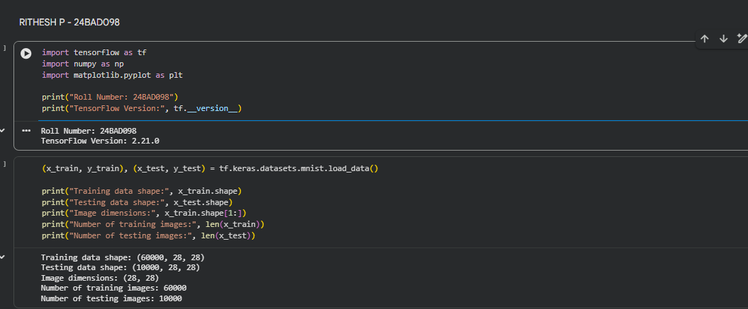
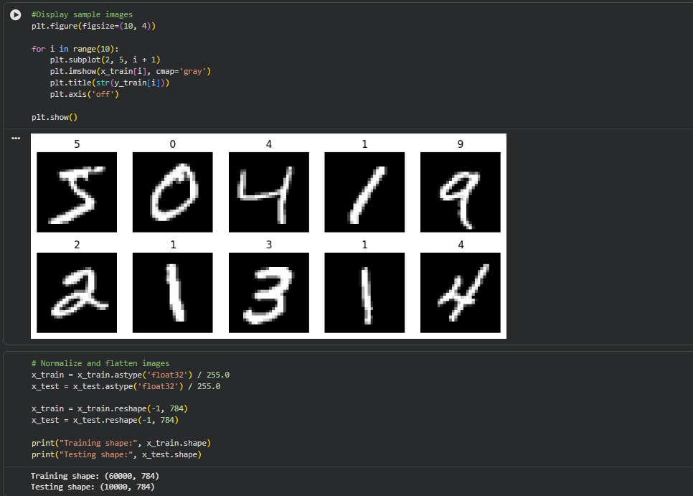
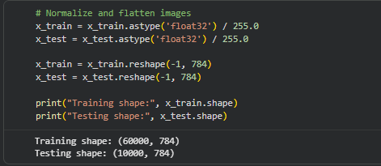
PART B: IMPLEMENTING THE ENCODER AND DECODER
Perform the following tasks:
- Define the input layer with 784 features.
- Build the encoder using one or more Dense layers to map the input to a smaller latent dimension, such as 32 features.
- Build the decoder using Dense layers to map the latent representation back to 784 output values.
- Use suitable activation functions, such as ReLU for hidden layers and Sigmoid for the final layer.
- Combine the encoder and decoder into a single autoencoder model.
- Display the encoder, decoder, and autoencoder model summaries.
CODE:
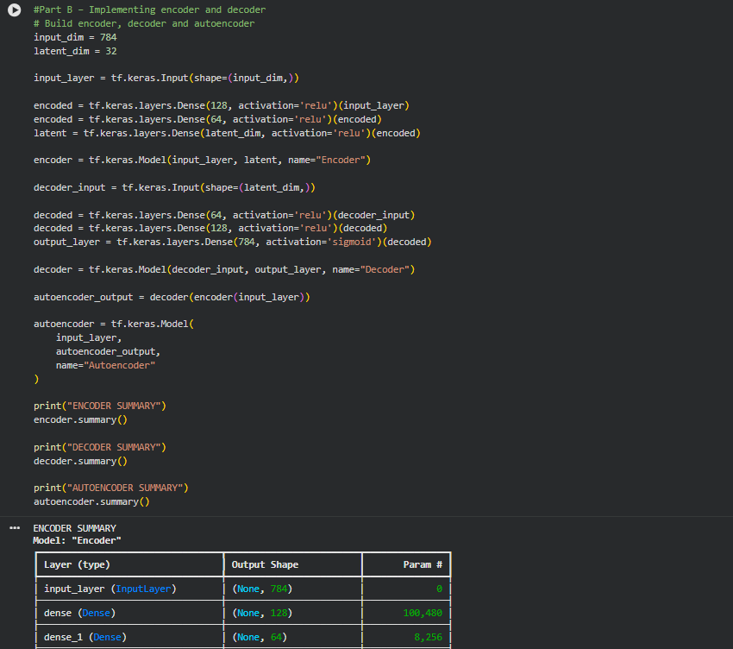
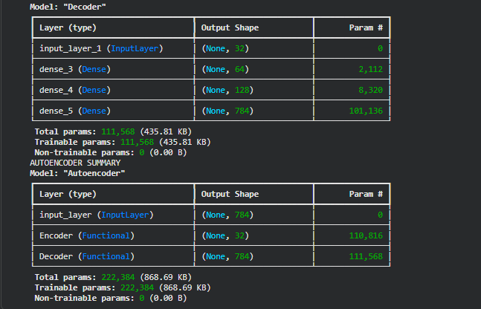

PART C: COMPILING AND TRAINING THE AUTOENCODER
Perform the following tasks:
- Compile the autoencoder using an optimizer such as Adam.
- Select an appropriate reconstruction loss, such as binary cross-entropy or mean squared error.
- Train the model by supplying the input images as both input data and target data.
- Use a suitable batch size and number of epochs. For example, use a batch size of 256 and 10 epochs.
- Validate the model using the test dataset or a validation split.
- Record training and validation loss for each epoch.
- Plot the training and validation loss curves to observe the reconstruction performance.
CODE:
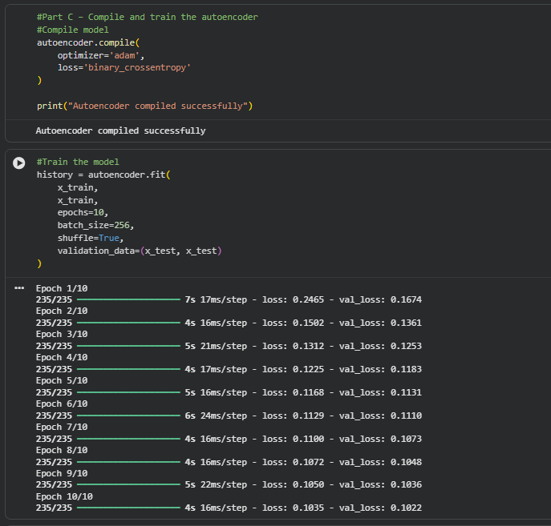
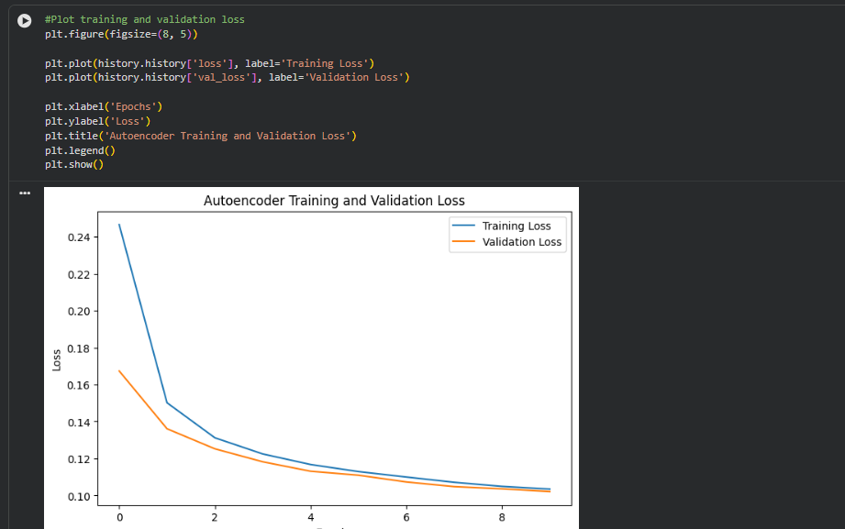

PART D: DIMENSIONALITY REDUCTION, FEATURE LEARNING AND RECONSTRUCTION
Perform the following tasks:
- Use the trained encoder to convert test images into lower-dimensional latent feature vectors.
- Display the original input dimension (784) and latent dimension (for example, 32).
- Pass the latent vectors through the decoder to reconstruct the images.
- Display original images and their corresponding reconstructed images side by side.
- Compare the original and reconstructed images and comment on the information retained or lost.
- Optionally, use PCA or t-SNE to visualize latent features in two dimensions, if covered in the course.
- Save the trained model or reconstructed images if required.
CODE:
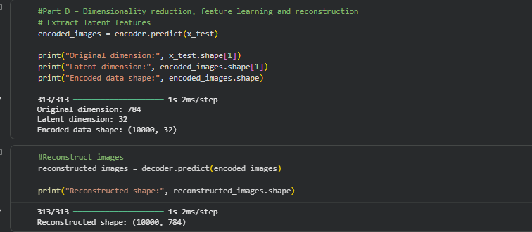
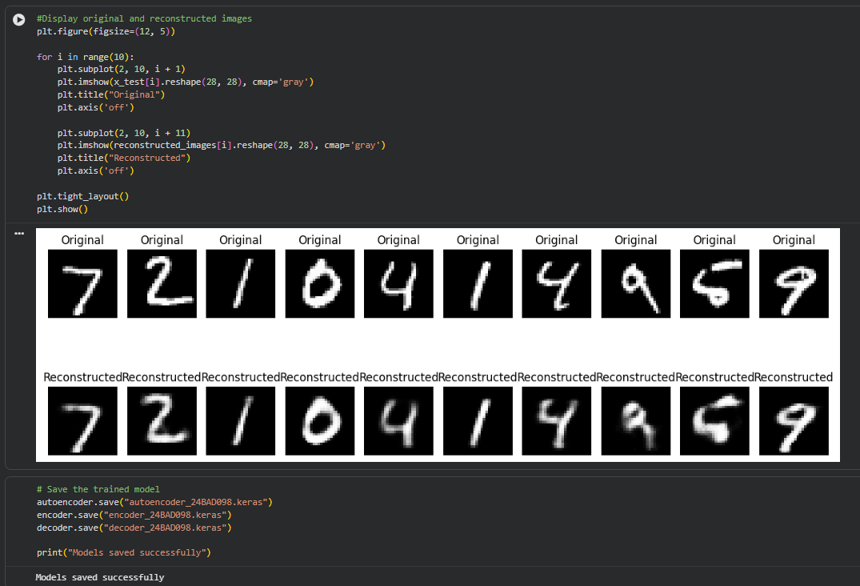

EXPECTED OUTCOME
Students will understand the architecture and working of a simple autoencoder and the roles of its encoder, latent representation, and decoder. They will learn to preprocess data, train the model using reconstruction loss, reduce input dimensionality, and extract compact latent features. They will evaluate the autoencoder by examining training and validation loss and comparing original images with reconstructed images.

POST-LAB QUESTIONS (PROVIDE BRIEF ANSWERS TO THE FOLLOWING QUESTIONS)
1. What is the main purpose of an autoencoder?
The main purpose of an autoencoder is to learn compressed representations of input data. It reduces the dimensionality of the data. It also learns important features automatically. It reconstructs the original input from the compressed representation.

2. How do the encoder and decoder differ?
The encoder compresses the input data into a smaller representation. It extracts important features from the input. The decoder receives the compressed representation. It reconstructs the original data from those features.

3. What is a latent representation?
A latent representation is a compressed version of the input data. It contains the important information needed for reconstruction. It is produced by the encoder. It is passed to the decoder to generate the output.

4. How does an autoencoder perform dimensionality reduction?
An autoencoder uses its encoder to reduce the input dimensions. It converts high-dimensional data into a smaller latent representation. Important features are retained in this process. This helps represent data using fewer dimensions.

5. Why are the input images also used as target outputs during training?
An autoencoder is trained to reconstruct its original input. Therefore, the same image is given as both input and target output. The model compares its reconstructed image with the original image. It learns to minimize the reconstruction error.

6. What does reconstruction loss measure?
Reconstruction loss measures the difference between the original data and reconstructed data. It indicates how accurately the autoencoder reproduces its input. A lower loss indicates better reconstruction. It is used to train and improve the model.

7. What may happen if the latent dimension is too small?
A very small latent dimension may not store enough information. Important features of the input may be lost. This can reduce reconstruction quality. The reconstructed images may become unclear or distorted.

8. Mention one real-world application of autoencoders.
Autoencoders are used in image denoising applications. They learn to identify important image features. They remove unwanted noise from images. They produce cleaner reconstructed images.

SUGGESTIONS FOR DATASETS
- MNIST Handwritten Digits – https://www.tensorflow.org/datasets/catalog/mnist
- Fashion-MNIST – https://www.tensorflow.org/datasets/catalog/fashion_mnist
- CIFAR-10 – https://www.tensorflow.org/datasets/catalog/cifar10 (requires adapting the model for image inputs)

ASSESSMENT
Description | Max Marks | Marks Awarded
Pre Lab Exercise | 5
In Lab Exercise | 10
Post Lab Exercise | 5
Viva | 10
Total | 30
Faculty Signature

